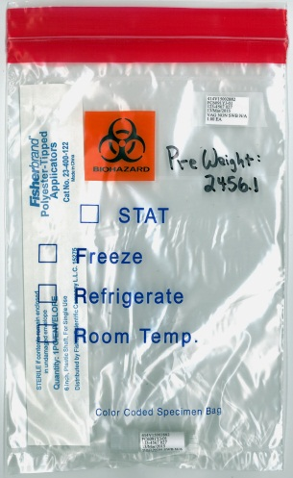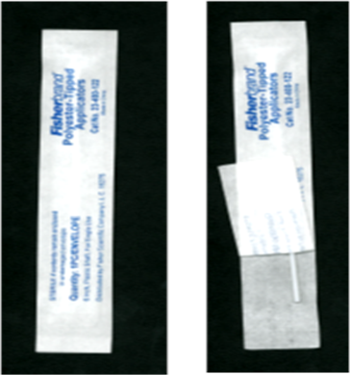**Vaginal Self-Collected Vaginal Swab for MTN-027**

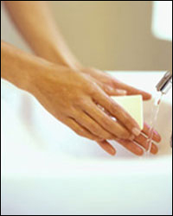



**1)** Wash & dry hands,

Then undress from the

waist down.

**2)** Open Zip-lock bag.

Remove cryovial with cap

and swab envelope from bag. **3)** Open swab envelope on the end

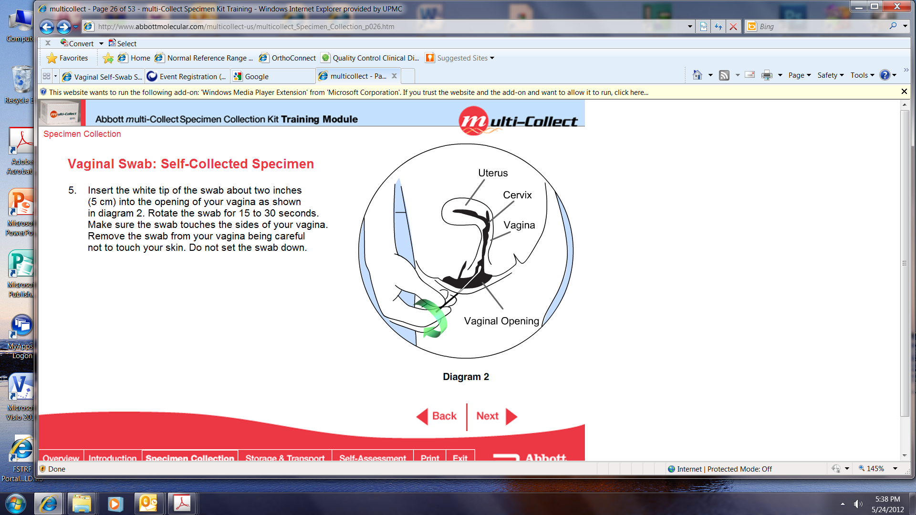  opposite of the soft tip. **4)** Grasp swab as pictured. **5)** While separating the labia

*Make sure swab wrapper gets with one hand, use other hand placed back into ziplock bag. to hold the plastic swab shaft

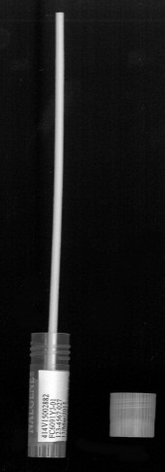 between thumb and forefinger.





**6)** Insert the soft tip of the swab into your vagina

approximately 2 inches (about the length of your

little finger). Spin the swab for 10 seconds (counting thousand 1, thousand 2…) in a circular

motion, attempting to touch all walls

of the vagina. **7)** Insert swab into vial

(hold upright) **8)** Place finger on the swab shaft so swab does not come out.

**NOTE: If the swab is dropped, please ask for**  Bend shaft back & forth to break off. **9)**  Place shaft & cryovial into **another collection bag and repeat the entire process** **above.** Cap cryovial containing swab tip. ziplock bag that also contains

the wrapper. Give to staff.

MTN-027 Self-collected Vaginal Swab Instructions 17Apr2015